**LIUNX AND SHELL SCRIPTING-LABORATORY**

**ASSIGNMENT – 1(G1)**

**Name**: Pranav mishra **REG NO**: 12114762

**ROLL NO**: **RDOC09A55** **Course Code**: CAP454

**Teacher**: Pallavi Ma’am **Course Title**: Linux and Shell Scripting-Laboratory

**Question-1:** **Move file1 from dir1 to dir2.**

Firstly, we create a file using cat command and write somethings in the file.

**Syntax:**  cat > filename

Then we make a directory using mkdir command then change the directory to root into dir2.

**Syntax:** mkdir directory name

Then move the file into directory use the following command after use the mv command then use the ls command.

**Syntax:** mv filename directory name

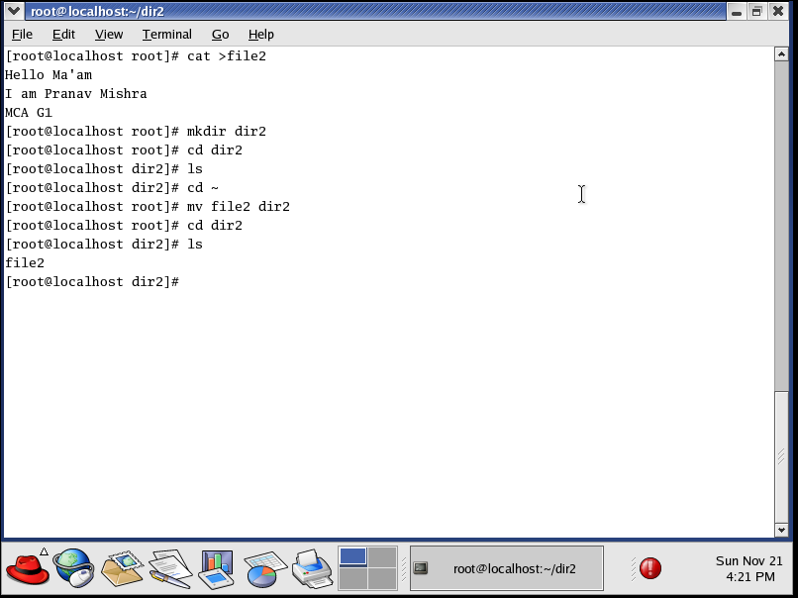

**Question-2: Replace a letter 'h' to 'a'.**

Firstly, we create a file using cat command and write somethings in the file.

**Syntax:**  cat > filename

Then use the following cat command to replace a letter ‘h’ to ‘a’.

**Syntax:** cat filename | tr “h” “a”

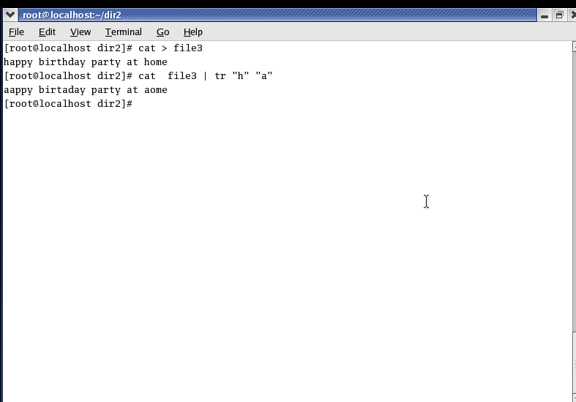

**Question-3: Cut first 5 lines of file1 and paste it into file2.**

Firstly, we create a file using cat command and write somethings in the file.

**Syntax:** cat>filename

Then use the following command Cut first 5 lines of file1 and paste it into file2.

**Syntax:** cut -b 1 -5 First filename | tee Second filename

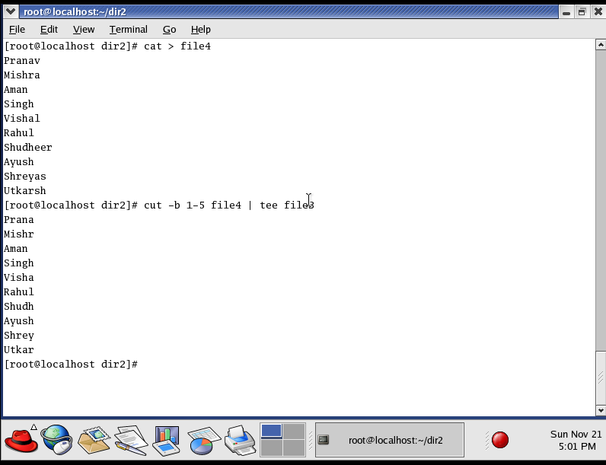

**Question-4: Get size of a file1.**

Firstly, we create a file using cat command and write somethings in the file.

**Syntax:** cat>filename

Then use the ls -sh command to get size of a file1.

**Syntax:** ls -sh

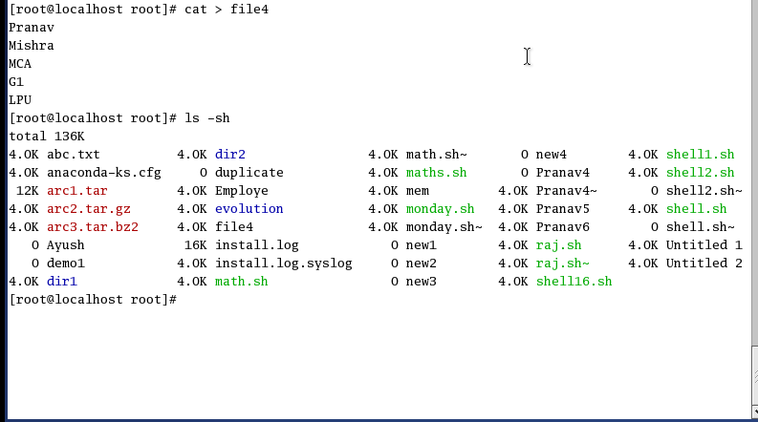

**Question-5: Create a group and add one new user in** it.

Firstly, we create a group using groupadd command and then create a user then use the following command.

**Syntax:** groupadd group name (for create a group)

useradd user name (for create a user)

usermod -G group name user name

cat /etc/group (for check the user and group)

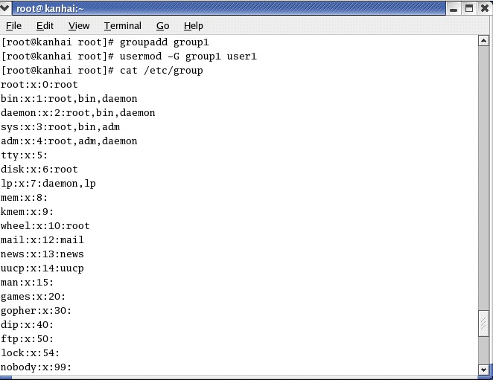

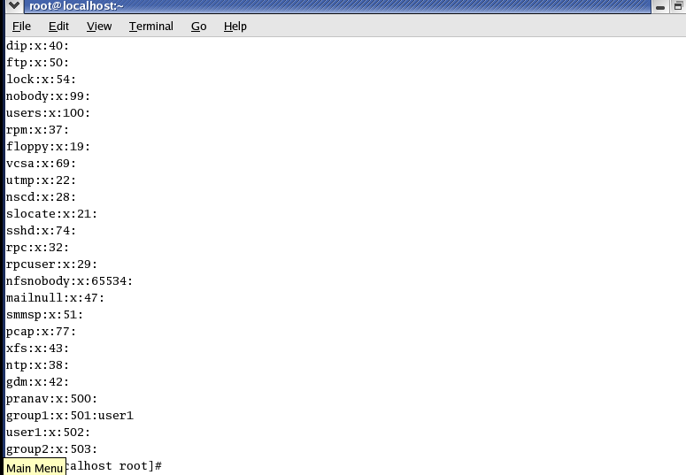

**Question-6: Check the IP address of your machine.**

To check the IP address of the machine, use the hostname -i command

**Syntax:** hostname -i

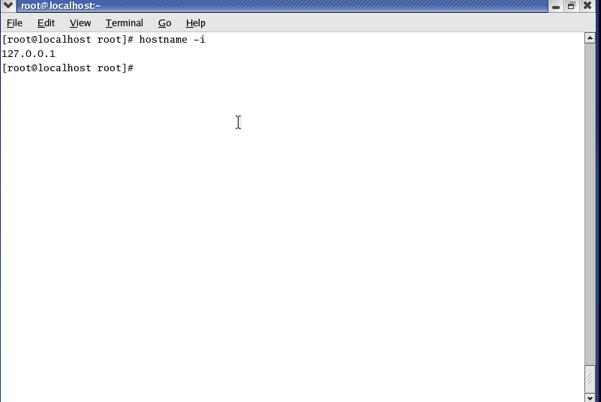

**Question-7: Create a shortcut of dir1.**

Firstly, we use the ls command to check all the file and directory

**Syntax:** ls

Then use mkdir to make a directory then use ln -s for create a shortcut of directory and then use the ls -lh to check the shortcut file.

**Syntax:** mkdir directory name (for make a directory)

ln -s dir3 dir3_soft

ls -ln

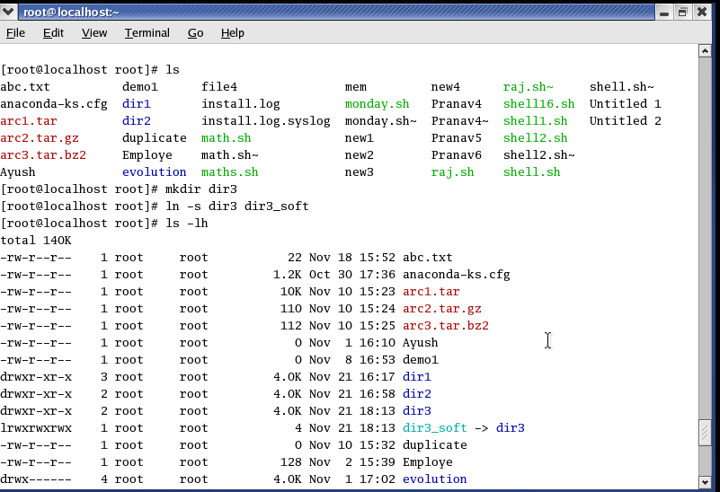

**Question-8: Sort content of file1 and store in file2.**

Firstly, we create a file using cat command and write somethings in the file.

**Syntax:** cat > filename (for create a file)

Then use the sort command for sort the content of one file to another file.

**Syntax:** sort first filename | tee second filename

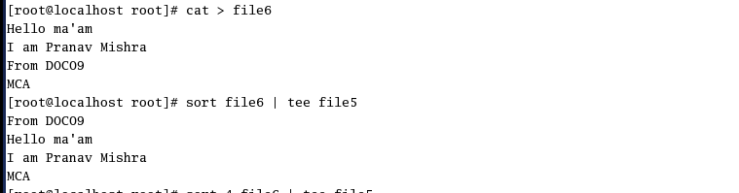

**Question-9: Change the default file permission of file2 to no execute permission to others.**

Firstly, we create a file using ls command to check all the file and directory.

**Syntax:** ls (for check all file and directory)

Then use the chmod command to change the default permission of any file and use the ls -l command to check the file permission.

**Syntax:** chmod 6 filename (for change the default permission of file)

ls -l filename (for check the permission of file)

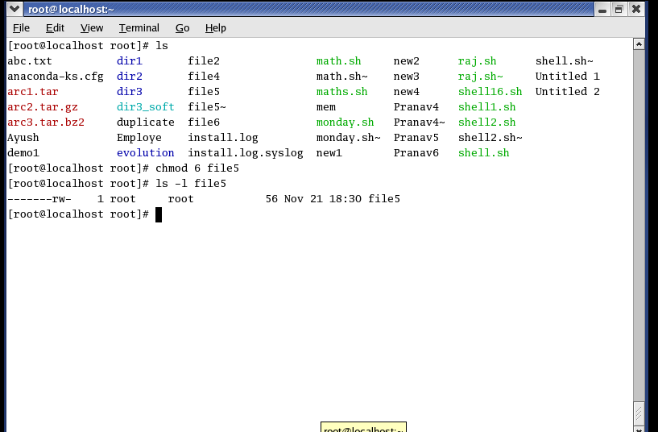

**Question-10: Write a command that will look for files with an extension "c", and has the occurrence of the string "apple" in it.**

Firstly, we create a file using gedit command .c extension and then use the find ./ -name “*.c” | xargs grep -I “apple” for check the data of the fie.

**Syntax:** gedit filename with .c extension (for create .c extension)

find ./ -name “*.c” | xargs grep -I “apple”(for check the data of the file)